**Radar Lab Data**

Distance = 1.5cm

Fan 12V 0.13A

HB100 5V 0.04A

Sampling rate 48.83kS/s

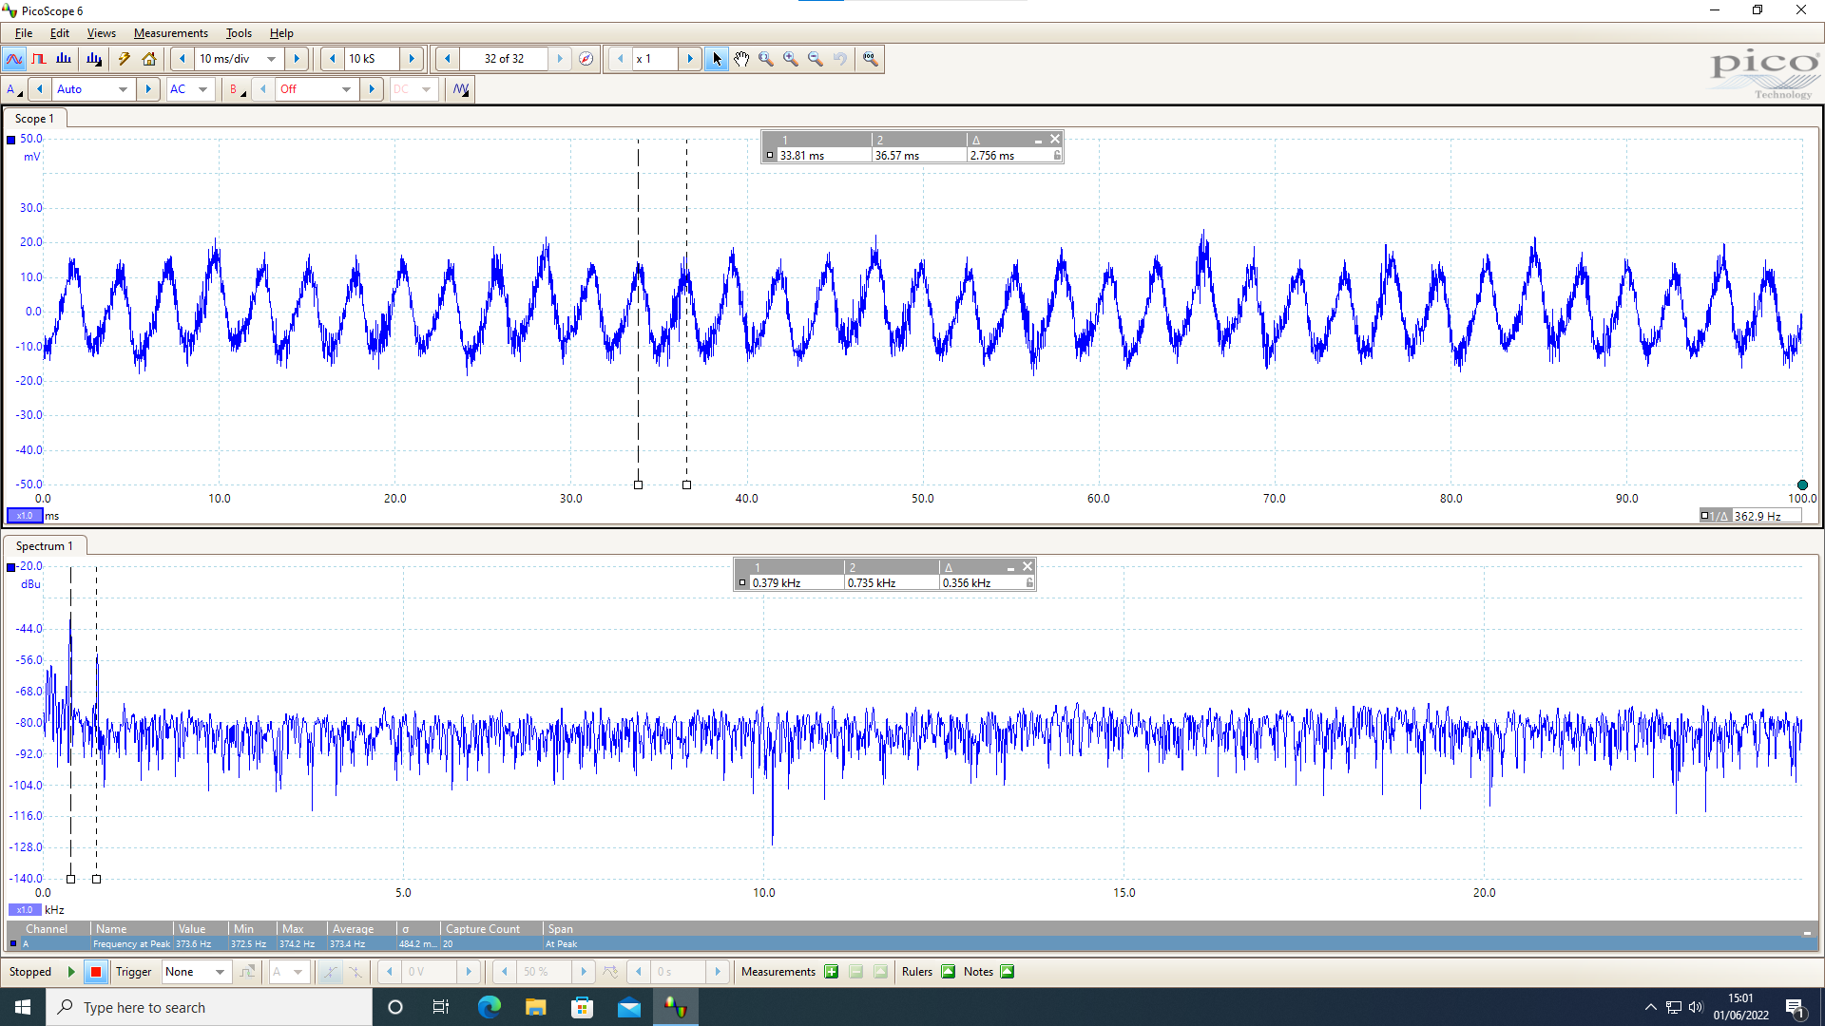

T = 2.756ms

$∆$ f = 377Hz

IF has a DC of -160mV

IF after ac coupling:

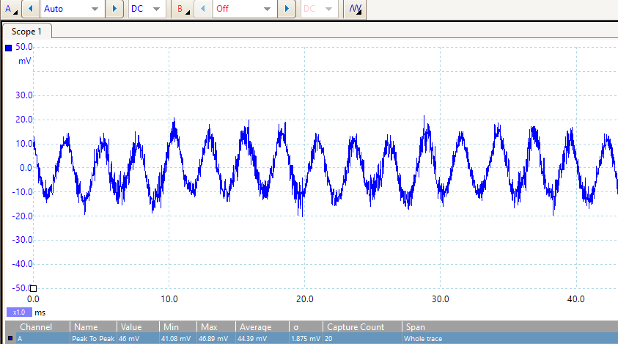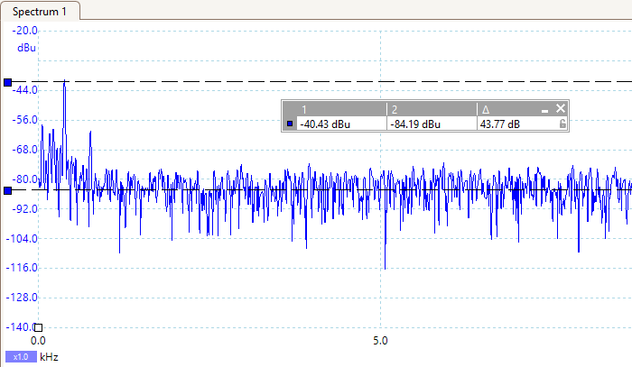

p-p = 44mV, amplitude = 22mV

Noise of the signal:

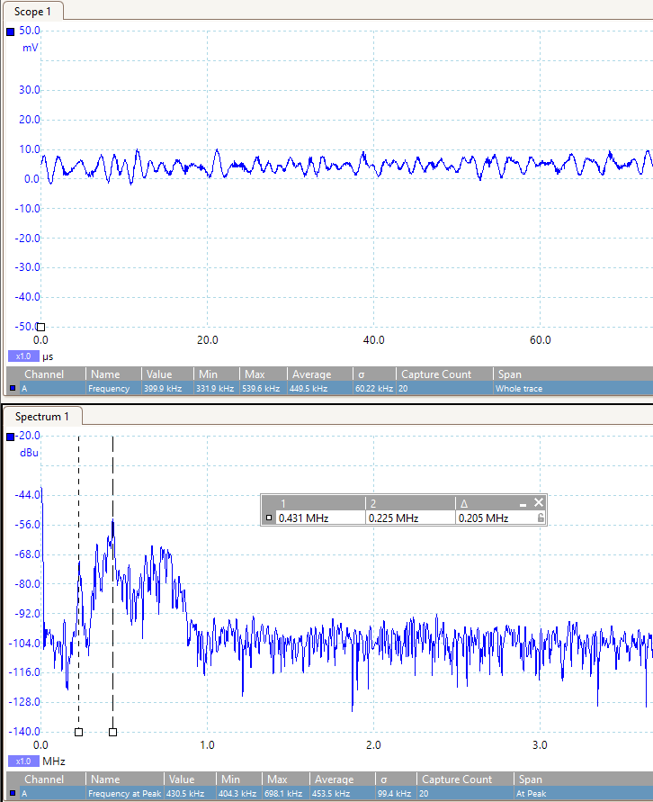

Min noise frequency = 225kHz

Max noise frequency = 431kHz

With sampling rate 12.21kS/s

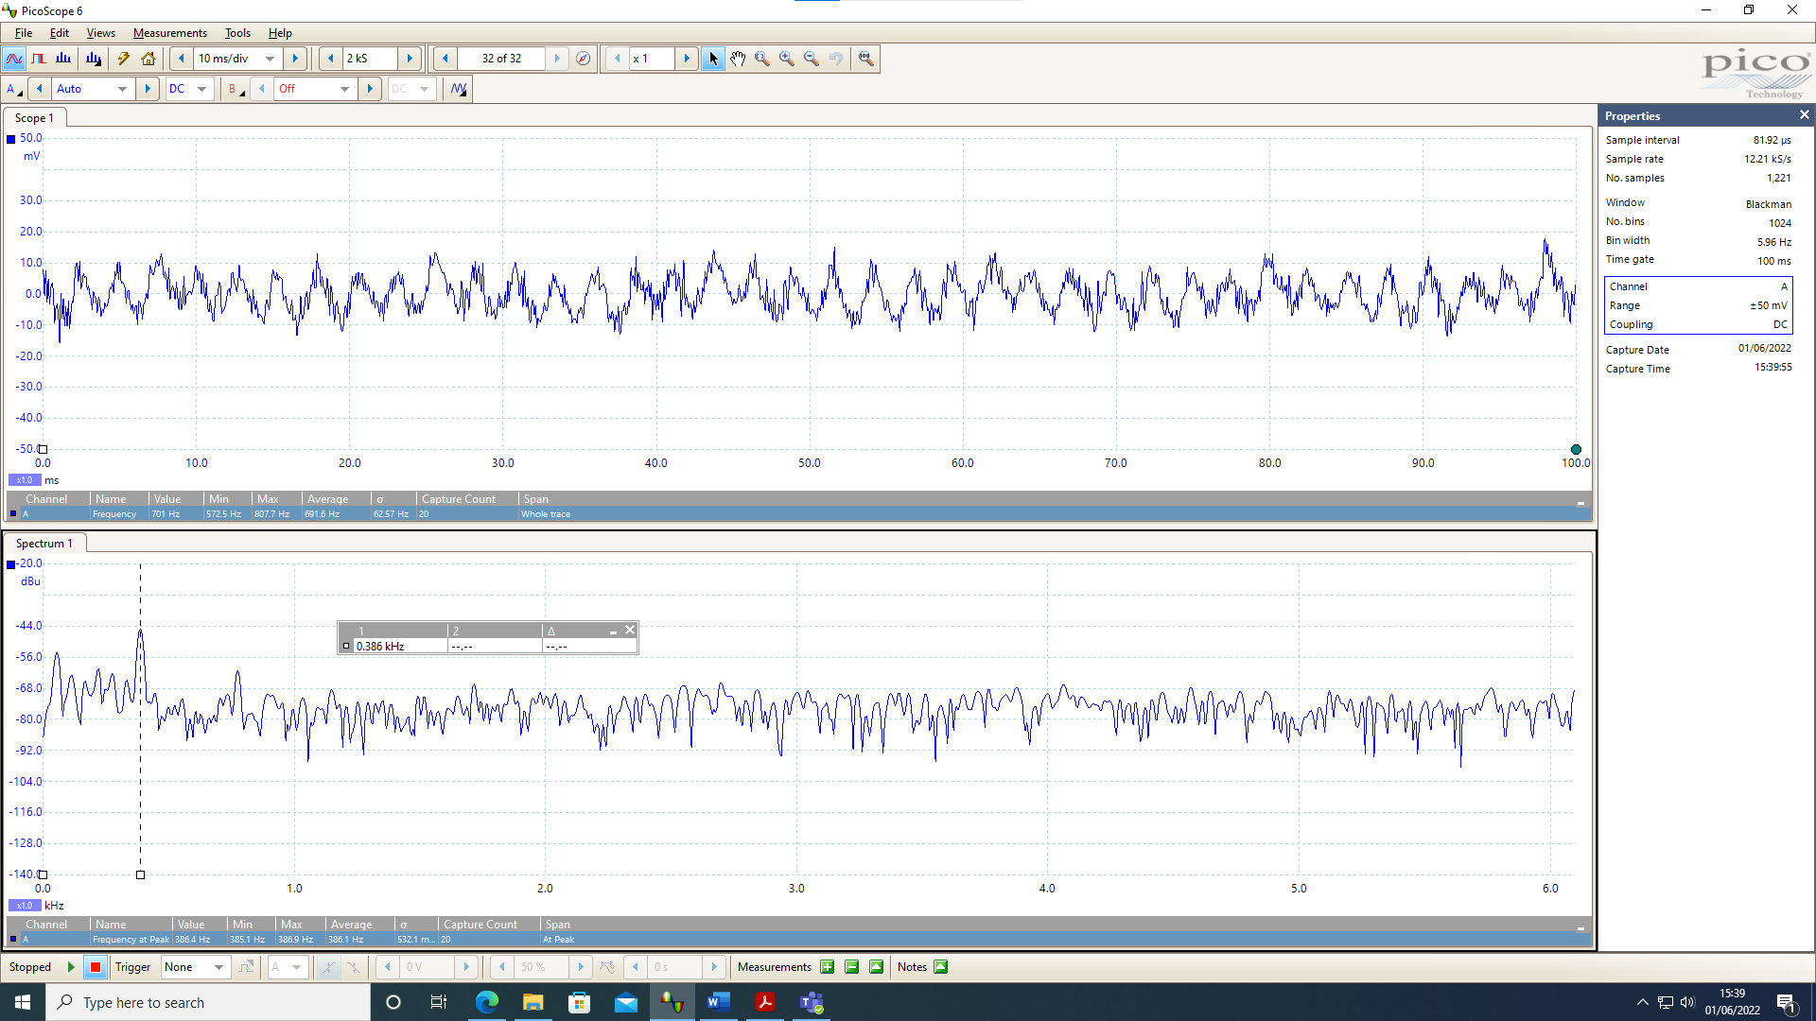

Noise of the signal:

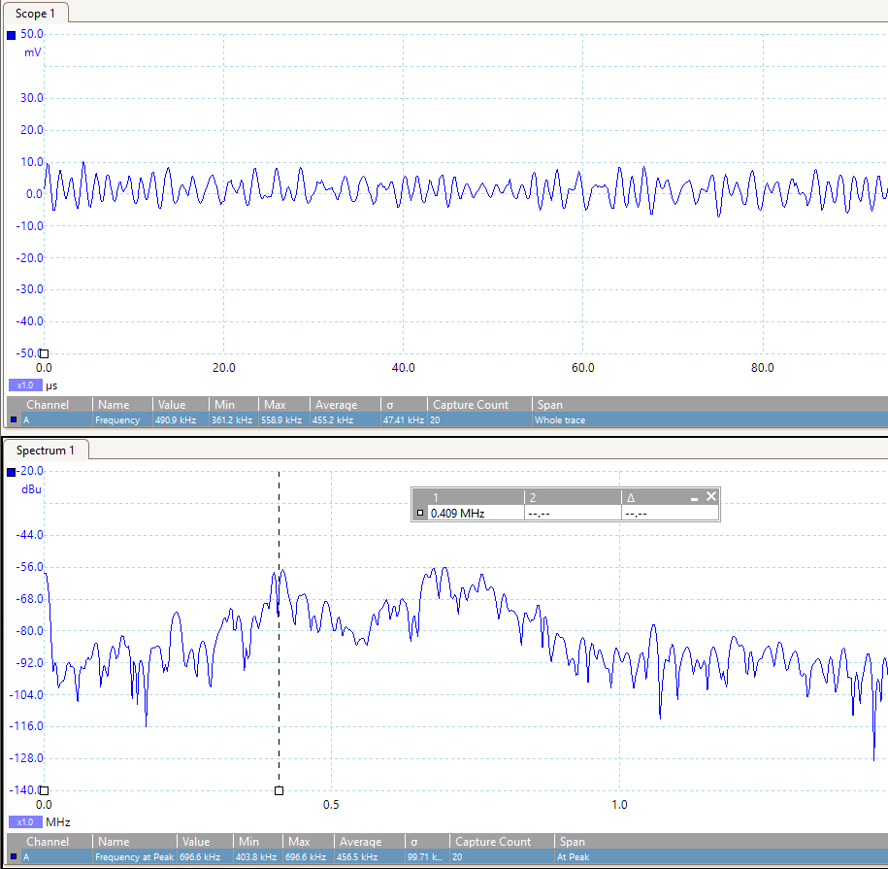

Approximately the same as before

f noise 450kHz

With target off

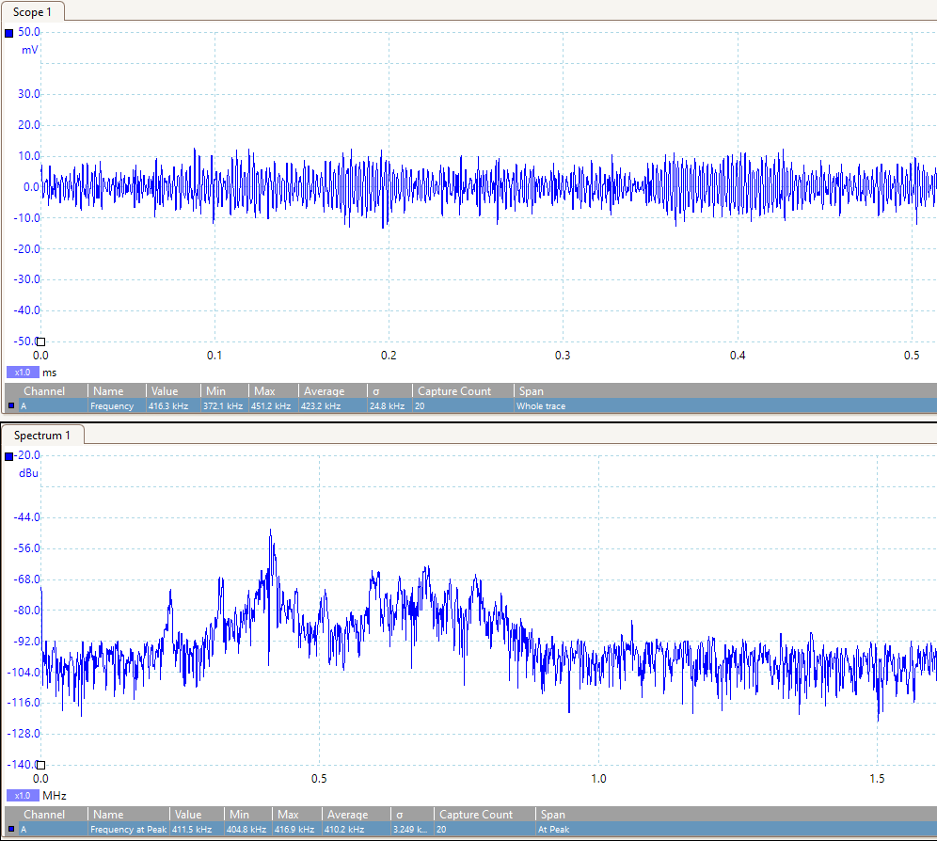

A constant noise f of 410kHz is detected

With target sideways

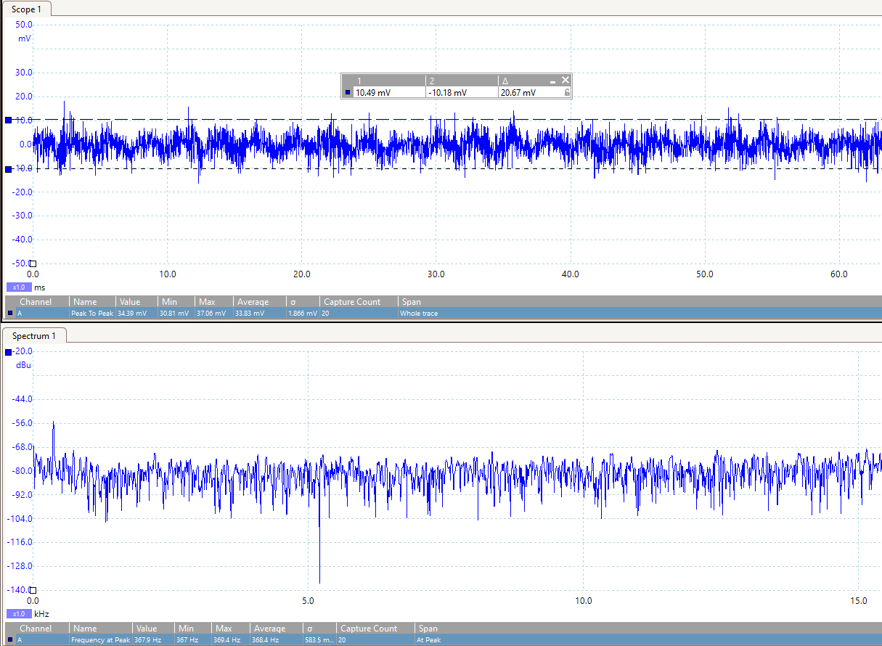

$∆$ f = 368Hz (around 370Hz)

p-p = 20mV, amplitude = 10mV (decreases a lot

Target distance 11cm

(the farthest distance can be detected)

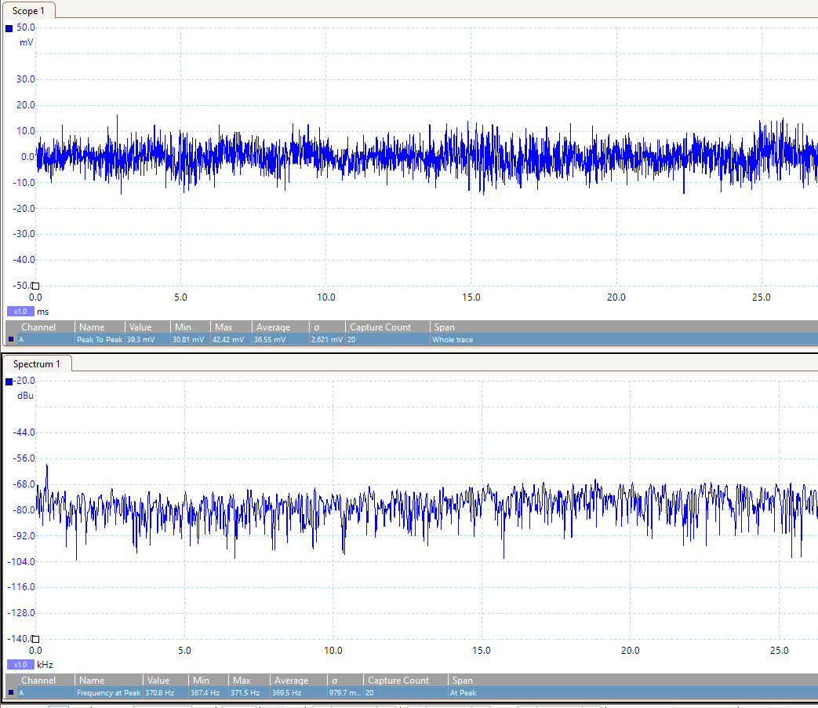

* 1. Then use the knowledge you gained to:
  2. a. suggest a method for clutter rejection LP filter
  3. b. estimate the signal amplification required (use the radar range equation to estimate the effect of distance)

Using the amplifier circuit

Distance 2cm

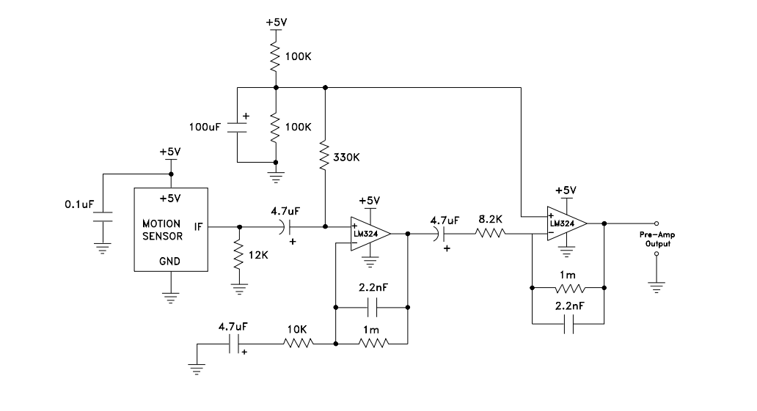

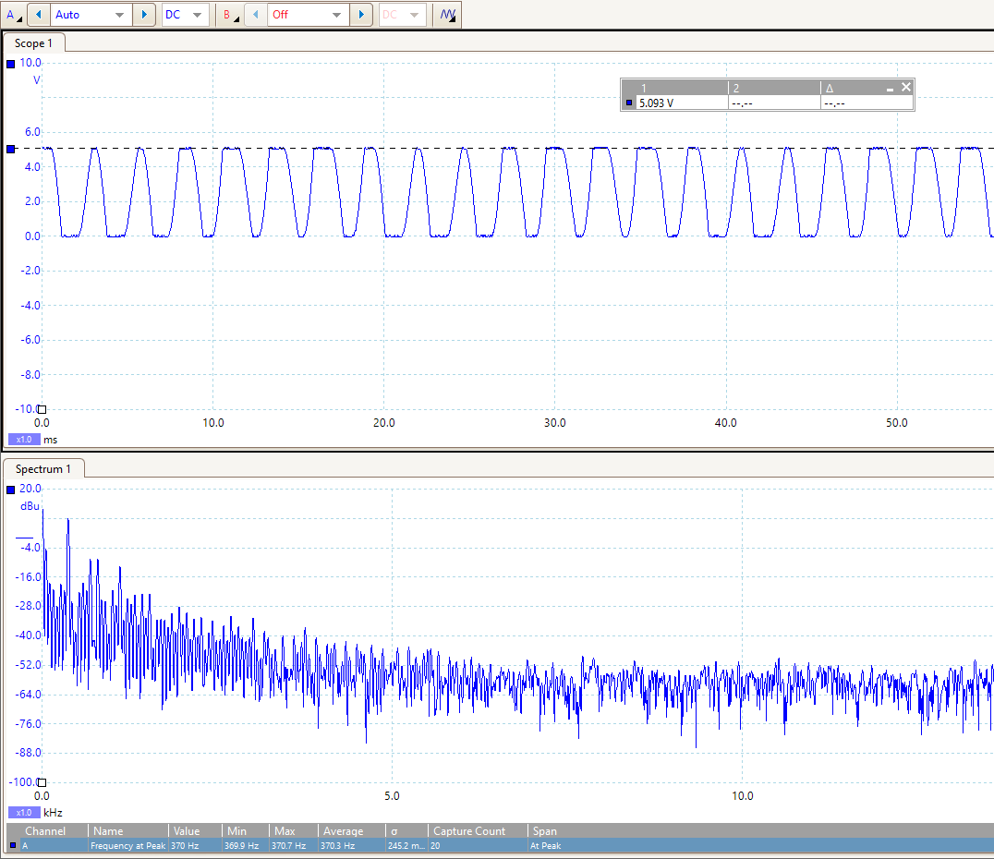

Output amplitude 0-5V (amplified)

$∆$ f = 370Hz as expected

Distance 9cm

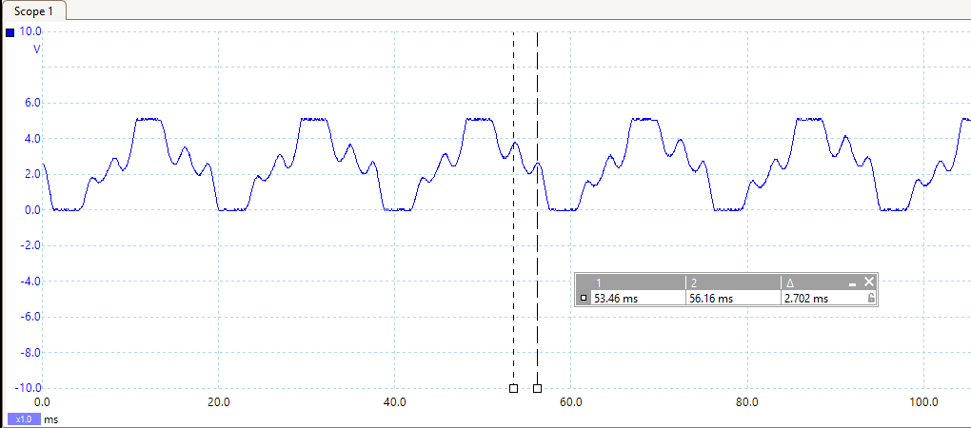

Frequency = 380Hz

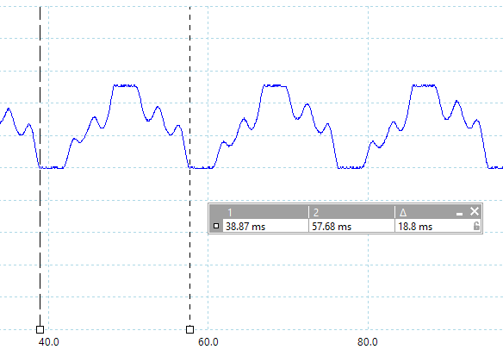

Frequency = 53Hz

(Need a bigger gain after filtering out the 50Hz at a larger distance)

Test the band pass filter (Fc=370Hz)

Input 370Hz Gain 0.96 (target signal pass)

Input 50Hz Gain 0.08 (filter out the 50Hz noise)

Input 4k Hz Gain 0.027 (filter out the noise at 4k Hz)

Gain -3dB at about 850Hz & 115Hz

Signal after both circuits at distance 8cm (expected distance)

In front of radar 1.2-1.4v

On the left hand side of radar (1 fan distance) 1.2v

(2 fans distance) 0.6v

Right hand side (1 fan distance) 0.8v

2 fans distance

3 fans distance (0.2v)

Signal after peak detector (8cm)

Degree 22 0.8v

27 0.6v

40 0.2v